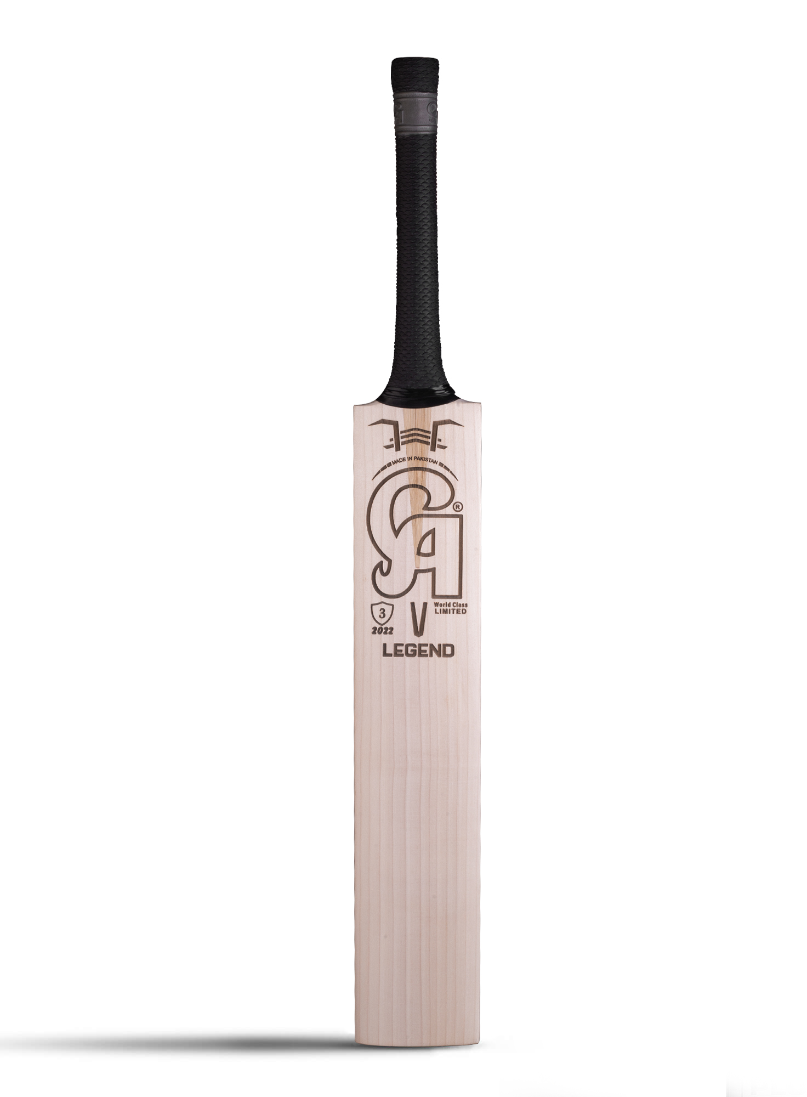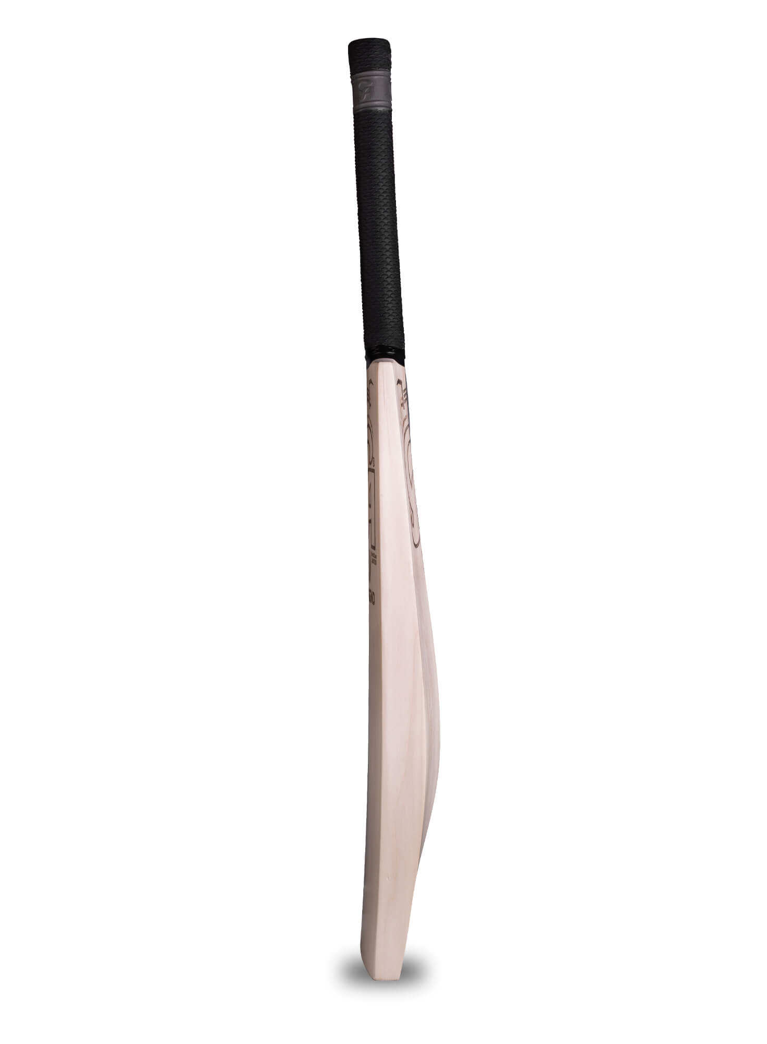

CA SPORTS LEGEND BAT

Legends are not made overnight, they take years to reach perfection, CA Sports making cricket bats since 1958. The apex of craftsmanship can be seen and experienced with CA Legend Bat. Ideally selected English willow cleft is handcrafted by seasoned and experienced makers who carve out each corner with perfection and fulfillment. 12 plus straight grains and all clear as this cricket bat does not come with a sticker or decal but a laser carving showing the see thoroughness of this ideal cricket bat. Bat's grip is sealed with CA's emblem that means it's parallel in quality. Each bat comes with a unique number lasered directly on the bat. Bat's toe is protected by Glass Protek technology to prevent its toe from weather conditions and chipping off. CA legend bat comes in a special packing that justifies its prestige.

**DETAILS:**

* 12 Plus straight grains
* The very responsive grip on strongly bonded cane handle
* Handcrafted by top-notch craftsmen of CA Sports